Battery Level Reading Circuit

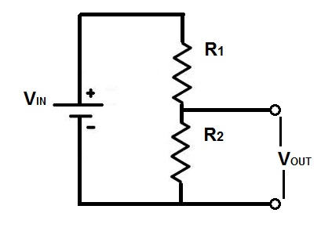

V­in = 14.6V max / 10.5 min

R1 = 47000Ω

R2 = 4700Ω

Ratio of R2 to R1 = 1/10 meaning R1 can be 4.3MΩ if R2 is 430kΩ

Vout = 1.33V max / 0.9595V min

1.1v read = 12.1v battery